1. Crie o Layout abaixo:

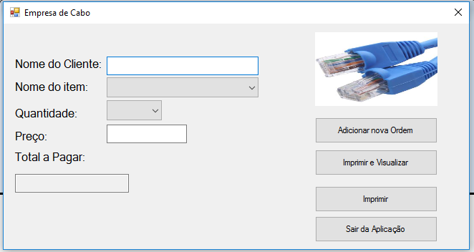

1. Insira os componentes abaixo:

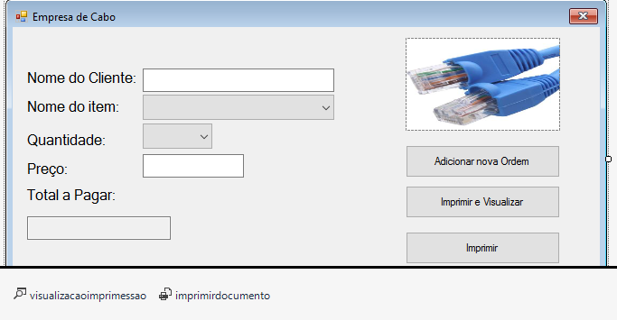

1. Printdocument e PrintPreviewControl.
2. Segue o código a ser inserido:

using System;

using System.Collections.Generic;

using System.ComponentModel;

using System.Data;

using System.Drawing;

using System.Linq;

using System.Text;

using System.Threading.Tasks;

using System.Windows.Forms;

namespace imprimir1

{

public partial class Form1 : Form

{

public Form1()

{

InitializeComponent();

}

private void adicionar_Click(object sender, EventArgs e)

{

nomecliente.Clear();

nomeitem.SelectedIndex = 0;

quantidade.SelectedIndex=0;

preco.Clear();

totalpagar.Clear();

nomecliente.Focus();

}

private void sair_Click(object sender, EventArgs e)

{

Application.Exit();

}

private void preco_TextChanged(object sender, EventArgs e)

{

atualizar();

}

private void atualizar()

{

if (quantidade.Text != "" && preco.Text != "")

{

decimal totalprecopago = Convert.ToInt32(quantidade.Text) * Convert.ToInt32(preco.Text);

totalpagar.Text = totalprecopago.ToString();

}

else

{

totalpagar.Text = "0";

}

}

private void quantidade_SelectedIndexChanged(object sender, EventArgs e)

{

atualizar();

}

private void imprimirvisualizar_Click(object sender, EventArgs e)

{

visualizacaoimprimessao.Document = imprimirdocumento;

visualizacaoimprimessao.ShowDialog();

}

private void imprimirdocumento_PrintPage(object sender, System.Drawing.Printing.PrintPageEventArgs e)

{

e.Graphics.DrawString("Nome do Cliente:" + nomecliente.Text, new Font("Arial", 12, FontStyle.Regular), Brushes.Black, new Point(25, 180));

e.Graphics.DrawString("Data:" + DateTime.Now, new Font("Arial", 12), Brushes.Black, new Point(25, 200));

e.Graphics.DrawString(traco.Text , new Font("Arial", 12), Brushes.Black, new Point(25, 250));

e.Graphics.DrawString("Nome do Item:", new Font("Arial", 12, FontStyle.Regular), Brushes.Black, new Point(25, 280));

e.Graphics.DrawString("Quantidade:" , new Font("Arial", 12, FontStyle.Regular), Brushes.Black, new Point(500, 280));

e.Graphics.DrawString("Preço:", new Font("Arial", 12, FontStyle.Regular), Brushes.Black, new Point(700, 280));

e.Graphics.DrawString(traco.Text, new Font("Arial", 12), Brushes.Black, new Point(25, 300));

e.Graphics.DrawString(nomeitem.Text, new Font("Arial", 12, FontStyle.Regular), Brushes.Black, new Point(25, 320));

e.Graphics.DrawString( quantidade.Text, new Font("Arial", 12, FontStyle.Regular), Brushes.Black, new Point(530, 320));

e.Graphics.DrawString("RS."+ preco.Text, new Font("Arial", 12, FontStyle.Regular), Brushes.Black, new Point(700, 320));

e.Graphics.DrawString(traco.Text, new Font("Arial", 12), Brushes.Black, new Point(25, 450));

e.Graphics.DrawString("Total a Pagar:" , new Font("Arial", 12, FontStyle.Regular), Brushes.Black, new Point(25, 475));

e.Graphics.DrawString( totalpagar.Text, new Font("Arial", 12, FontStyle.Regular), Brushes.Black, new Point(700, 475));

e.Graphics.DrawString(traco.Text, new Font("Arial", 12), Brushes.Black, new Point(25, 500));

}

private void imprimir_Click(object sender, EventArgs e)

{

imprimirdocumento.Print();

}

}

}